News Release
Local Church Renews Commitment to Downtown Beaufort
December 26, 2019
Contact: info.fbcbeaufort@gmail.com
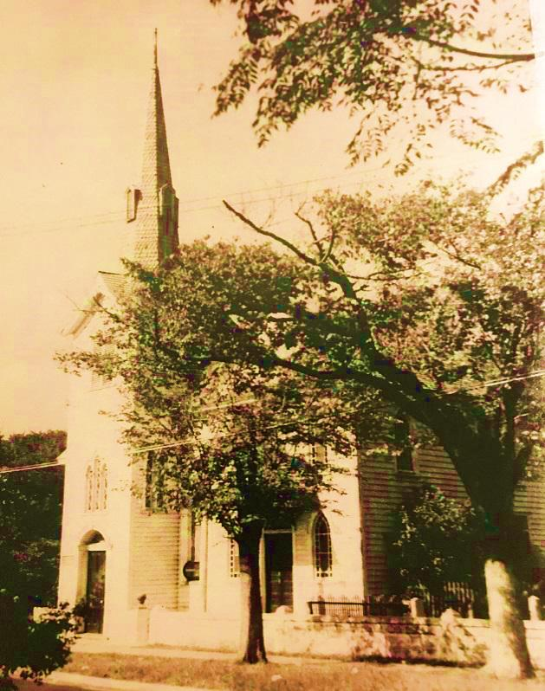
The congregation of the First Baptist Church in downtown Beaufort voted to adopt their 2020 Vision Plan, which includes the renovation of the one hundred sixty-eight year-old church. Located on the corner of Ann and Turner Streets, the church has been a house of worship and fellowship for hundreds of families in Beaufort and the surrounding communities.
In addition to maintaining its presence in the Downtown Business District, the First Baptist Church also supports Outreach Ministries and Missions in our area’s communities as well as national and international missions
Church members considered selling its downtown real estate and relocating out of the Historic Downtown neighborhood. Members believe it will be a testimony of God’s presence in our community to maintain His House as a Shining Star and a Harbor of Hope in the Heart of Beaufort. The church plans to raise the money from the congregation and community to cover the renovation cost, but funding has been arranged by First Citizens Bank which has provided banking services to the church for many years.
The renovations are scheduled to begin in the spring of 2020. The project’s scope will include exterior and interior improvements. The primary focus is Handicap Access throughout the building as well as parking, entrances and exits. Architect Darden J. Eure, III “Tripp” of mbf architects pa in New Bern plans a portico on the Turner Street side of the building featuring a cupola bell tower utilizing the bell from the original church built in 1851.
21st Century Builders Incorporated will be managing the renovation for the church with plans to use as many local contractors as possible. General Manager Dean Graham of 21st Century Builders Inc. plans to work throughout the process to avoid interruptions to current activities as much as possible.
In a related project, The Beaufort Downtown Parking Lot on the corner of Ann and Turner Streets has plans for renovation, fencing, and the addition of a buffer area around the existing lot. The new parking lot will utilize gated entrance and exit lanes allowing the community, visitors and businesses to utilize the lot as they choose.
Everette S. “Rett” Newton, Mayor, Town of Beaufort NC stated that, “Beaufort’s First Baptist Church is a pillar of our community. This thoughtful initiative will safeguard the future of the church in our historic district, add to our Town tax base, and preserve parking to facilitate commerce downtown. This is clearly great for Beaufort.”

